Strategies for supporting your child with ADHD to do school work / activities
Set boundaries, rules and expectations – make these clear and simple. It is helpful to have your child repeat back rules, expectations or other instructions to make sure they are understood. | 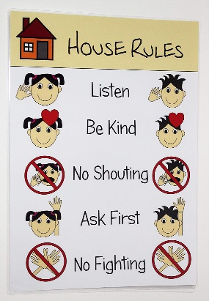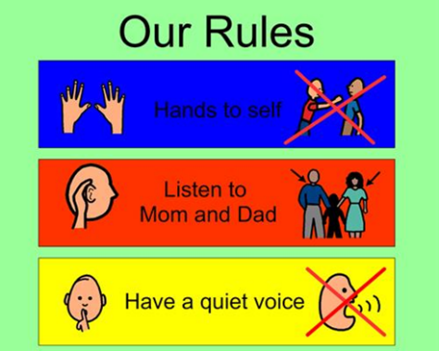
 | Find a place that is quiet and limit distractions - close doors, turn off the TV or phone…
Give your child lots and lots of immediate praise and feedback about their behaviour. | 
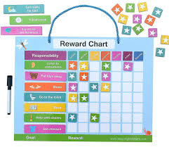   | Use rewards and incentives before telling your child off for unwanted behaviours. This will motivate your child and help keep your home feeling like a positive place. Change the rewards frequently to help prevent your child from becoming bored.

Allow your child frequent physical breaks to move around. Try not to prevent your child from playing and being active as a consequence / sanction for negative behaviours. Children with ADHD benefit from the physical movement and can usually focus better following exercise. | 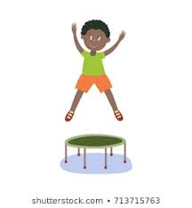
 | Allow some restlessness at work area. Allow your child to stand up or lie on the floor or lean on the table if it helps them stay on task.
Reduce your child’s total workload. Break work down into small sections with breaks in between. Tell your child what the structure is so they know how long they’ll be working and what the activity is. Make a chart, draw a picture or write a list and tick off the activities once they’re done. | 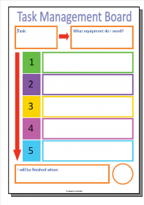
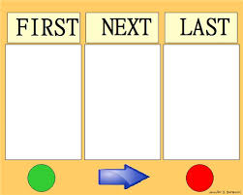 | Give clear, simple directions. Avoid “overloading” with too much information. Use timers and time signals to tell your child how much time they have to focus on the activity.
Catch your child being good and give them immediate praise. Ignore negative behaviours that are minimal and not disruptive.  Be as positive as you can. Collect rewards like stickers or tokens that can be collected to get a treat when they’ve completed an activity or followed an instruction. | 
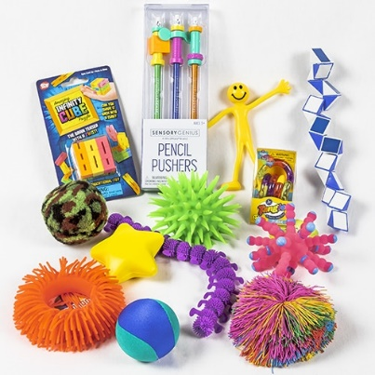 | Your child might like to hold a ‘fiddler’ like a squishy ball or piece of blu tac. This stimulation often helps children with ADHD to calm down and focus. They may have used one before in school.
Schedule the most difficult subjects in the morning time when your child is fresher and less tired. | 

