

**Supporting Spelling-**

**A Guide for Parents**

Many children struggle to learn and remember spellings. A lot of words can be spelt phonetically so in the first instance, children should be encouraged to use their phonic knowledge when spelling, breaking words down into sounds. However, there are also many common exception words that cannot be spelt phonetically and so children need to remember these spellings. There is no single method to support remembering spellings as every child is different. Below are some examples of different methods you could try to support your child to learn their spellings. Repetition is key so practising for 5 minutes every day will be more effective than for 30 minutes once a week.

**Learning Spellings**

1. **'Look, Cover, write, say, check'**

This is the most common method of learning spellings but it does not always work for some children. By adding the steps below it can help the spelling to be remembered more easily

* Target a few words little and often.
  + Write the target word large and clear onto card.
  + Hold the word to his/her upper left.
  + Discuss the visual appearance- number of letters, bits that stick up/down, patterns, words within words, colour any tricky parts.
  + Say the letters out loud.
  + Remove the card.
  + Ask pupil to name the letters forward.
  + Ask pupil to write the word from the mental image.
  + Check the word is correct.

1. **‘Make and Break’**

* Clap the syllables in the word several times and say it while clapping (stretching the word is also good to hear the sounds)
* Now ‘Make and Break’:
  1. Make the word –using magnetic letters or small letter tiles
  2. Break the word- into syllables
  3. Make the word- saying the syllables during the rebuild and repeating as necessary
  4. Break the word- into random letters
  5. Make the word- saying **letter names** during the rebuild

1. **Multi-sensory ideas for teaching spelling (this can work for children of all ages not just younger ones).**

Practise writing spellings in

* Shaving cream
* Salt or sand
* Painting words or painting with water on the playground
* Hair gel, paint and glitter in a sandwich bag
* In the air
* On someone else e.g someone’s hand or back
* Tracing spellings on different textures such as sandpaper, silk, fur etc

Practise building spellings out of

* Pipe cleaners
* Lego
* Stones
* playdough

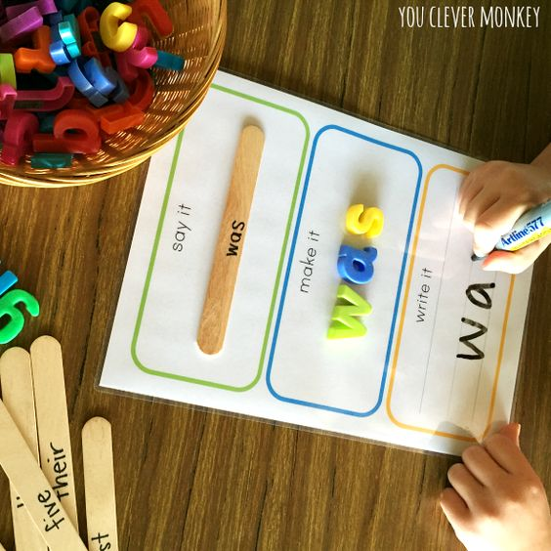 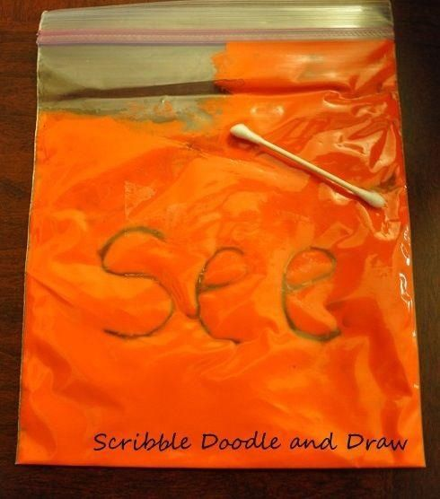

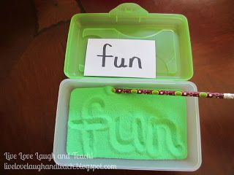 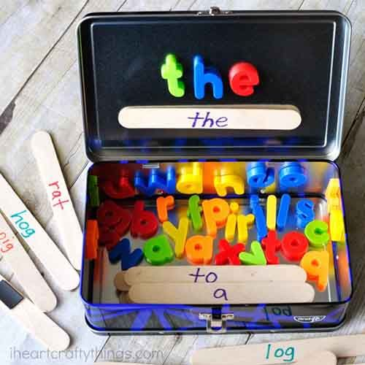

1. **Simultaneous Oral Spelling (SOS)**

* Suitable for regular and irregular words and develops a movement and auditory memory.
* Box 1: Teacher/ parent writes word and reads it. Learner repeats the word and traces over the word several times, saying the letter names.
* Box 2: The learner copies the word, saying the letter names.
* Box 3: Fold the paper over boxes 1 and 2. Learner writes the word from memory, saying the letter names. Check the attempt. Highlight 'tricky' parts of word if incorrect and repeat.
* Box 4: Learner writes the word with eyes closed.
* Box 5: Learner writes the word in a simple sentence.

|  |  |
| --- | --- |
| 1. | 2. |
| 3. | 4. |
| 5. | |

1. **Chaining and Reverse Chaining**

* Write the word as a whole Eg -soil
* Cover the word
* Underneath just write the first letter
* Underneath this write the first and second letter
* Underneath write the first, second and third
* Finally write the whole word

**Chaining or Reverse chaining**

Eg **soil soil**

s - - - l

s o - - i l

s o i - o i l

s o i l s o I l

Chaining and reverse chaining can also be done using magnetic letters.

1. **Websites and apps**

* Pocket Phonics
* Mr Thorne does phonics
* Mr Thorne’s Spellbook
* Spelling Shed
* Spelling Whizz
* Phonics tic tac toe
* [www.spellzone.com](http://www.spellzone.com)
* [www.topmarks.co.uk](http://www.topmarks.co.uk)
* <http://www.ictgames.com/lcwc.html>
* <https://spellingframe.co.uk/>

Practising Spellings

Once spellings have been learnt, they need to be practised regularly in order to retain them. Below are some easy ways to practise spellings.

**1) Word Search**

Create your own word searches using your spelling words. Or use this link to get your computer to do it for you. http://puzzlemaker.discoveryeducation.com/WordSearchSetupForm.asp

**2) Air spelling:**

Choose a spelling word. With your index finger write the word in the air slowly, say each letter. Your parent needs to remind you that you need to be able to 'see' the letters you have written in the air. When you have finished writing the word underline it and say the word again. Now get you parents to ask you questions the about the word. For example they could ask 'What is the first letter?' 'What is the last letter?' 'How many letters are there?' etc. You could also do this with a magic wand as well as your finger.

**3) Media Search:**

Using a newspaper or magazine you have 15 minutes to look for your spelling words. Circle them in different coloured crayon. Which of your spellings word was used the most times?

**3) Scrabble Spelling:**

Find the letters you need to spell you words and then mix them up in the bag. Get your parents to time you unscrambling your letters. For extra maths practice you could find out the value of each of you words.

**4) Pyramid Power:**

Sort your words into a list from easiest to hardest. Write the easiest word at the top of the page near the middle. Write the next easiest word twice underneath. Write the third word three times underneath again until you have built your pyramid

**5) Design A Word:**

Pick one word and write it in bubble letters. Colour in each letter in a different pattern.

**6) ABC Order:**

Write your words out in alphabetical order. Then write them in reverse alphabetical order.

**7) Story Time:**

Write a short story using all your words. Don't forget to check your punctuation!

**8) Simple Sentence:**

Write a sentence for each of your words. Remember each sentence must start with a capital letter and end with a full stop.

**9) Colourful Words:**

Use two different coloured pens to write your words. One to write the consonants and one to write the vowels. Do this a couple of times then write the whole word in one colour.

**10) Memory Game:**

Make pairs of word cards. Turn them all over and mix them up. flip over two cards, if they match you get to keep them, if not you have to turn them over again. Try and match all the pairs.

**11) Finger Tracing:**

Use your finger to spell out each of your words on your mum or dad's back. Then it's their turn to write the words on your back for you to feel and spell.

**12) Spelling Steps:**

Write your words as if they were steps, adding one letter each time. (It's much easier doing this on squared paper)

**13) Scrambled Words:**

Write your words then write them again with all the letters mixed up.

**14) Ambidextrous:**

Swap your pen into the hand that you don't normally write with. Now try writing out your spellings with that hand.

**15) Secret Agent:**

Write out the alphabet, then give each letter a different number from 1 to 26. (a = 1, b = 2, c = 3 ect.) Now you can spell out your words in secret code.

**16)** **Eyes closed**

Try to write your spellings with your eyes closed.

K. Griffiths June 2020