Practical ways for parents to work in partnership with schools to support children with motor difficulties
Dressing
Practice dressing skills with school uniform and PE kit at weekends and in the holidays. Share the strategies you use at home with school. Adapt clothing if necessary such as Velcro for buttons, elastic tie, sew in a bigger loop for child to hang coat or a key ring on a zip.
Independence Skills
Practice all the skills needed in a school day. These could be folding PE kit, opening packets for packed lunch, putting straws in drink cartons, using cutlery, scraping plate carrying plate/tray etc.
Reduce Frustration
Provide see through easy zip pencil case. Choose a lunch box that is easy to open. Wrap sandwiches in foil rather than cling. Choose easy open packages or part open and secure with a clip or peg.
Get organised
Help and support your child with organisation. Have a laminated timetable for their week at school and activities at home. Have a prompt or checklist by the front door to remind them of what needs to be taken on each particular day. Help them to manage their time with homework tasks and encourage them to work in low distraction place.

Activities to help develop skills and coordination

The following pages include some suggestions to help develop your child’s skills and coordination at home. They are activities that you can incorporate into your daily lives. Many of the activities are fun to do. You can also encourage brothers and sisters to join in. The activities aim to support in -

- Developing posture and internal stability
- Developing body awareness
- Developing shoulder and arm strength
- Developing hand and grip strength
- Developing finger skills
- Using two hands together

Developing posture and internal stability

Many young people with motor skills difficulties have low postural tone which means they have difficulty holding a position against the force of gravity. They often lean against furniture or people when sitting or standing, and when working at a table they will slouch forward or prop their head in their hands. People with low postural tone can tire easily.

Good posture is important to help children carry out movements using their hands. It means a child can sit up straight with their hands free for drawing, or can walk steadily while carrying their lunch tray. The following activities will help to develop the middle section of the body, the trunk, as a stable base from which to position and move the head, arms and legs.

- Encourage the child to lie on their tummy and prop themselves with their forearms. They could use this position while watching TV, reading a book or doing a puzzle.
- When reading at a table encourage the child to use both hands to hold the book while resting their elbows on the table.
- Encourage reaching-up activities such as placing magnets on a fridge at shoulder height, painting at an easel and passing shopping up for an adult to put onto a shelf, reaching up to pop bubbles.
- Swimming is great for developing trunk stability, particularly when swimming on the front.
- Encourage the child to lie across a swing while lifting their feet off the ground to swing gently.
- Ball games where the child has to lift a large lightweight ball and throw it up will help with trunk extension.

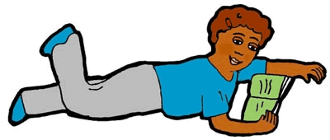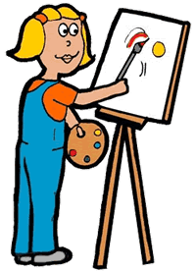

Developing body awareness

Many children with motor difficulties don’t seem to know where their body is in space and where parts of their body are in relation to each other. They may bump into things; have difficulty putting their foot into their shoe or over-reach when trying to pick up a drink.

Poor body awareness is often found in children who have low postural tone. This is because they don’t receive good feedback from their muscles and joints to tell them where their limbs are and how they are moving. Good body awareness helps us to adapt our movements to match the demands of our environment. It also helps us to develop spatial awareness.

Activities that put pressure through the joints and which make the muscles work against resistance are good for developing body awareness. These can include:

- Pushing a loaded shopping trolley
- Digging in the garden
- Carrying the laundry basket into the kitchen or pushing it along the floor
- Wearing a backpack whilst walking to school (not too heavy!)
- Sweeping leaves in the garden or sweeping the kitchen floor
- Many playground activities including swings, the see-saw and climbing frames

Activities that help a child to “feel” different parts of their body include:
- Crawling through a play tunnel
- Squeezing through spaces that are only just big enough
- Talk about the arms/legs/back as you rub them dry after a bath.
- Sing songs that mention body parts and touch those parts as you sing Head Shoulders Knees and Toes.
- Playing “Simon says” – getting the child to move different body parts and to copy your body positions.

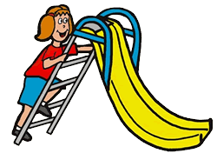
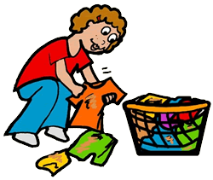

Developing shoulder and arm strength

Children with poor shoulder stability find it difficult to hold their arms in different positions while they use their hands to move toys and objects. They may also find it difficult to make smooth, controlled arm movements away from the centre of their body, for example to move a pencil across a page or to pour a glass of water. Children will often hold their elbows into their sides for extra stability.

Improving shoulder stability and upper limb strength will allow the child to make more accurate and controlled movements with their arms and hands. Activities that involve putting weight through the shoulder joints are especially helpful.

- Crawling through tunnels, pulling up a slide and climbing up a rope ladder.
- Ball games such as swing-ball and racket games can also help as the sensation of the ball hitting the bat/club stimulates the shoulders- use a large lightweight ball or a balloon to start with.
- Encourage your child to dig with a spade, pull a rake or push a wheelbarrow
- Ask your child to help you wash your car, reaching high and to the sides, and wringing the sponge out when it is too wet
- Ask your child to help you unload the washing machine then reach up to put the washing on the line.
- Games that require the child to hold their arms away from their body, such as magnetic fishing games, hoop-la or make skittles with empty plastic bottles.
- Painting at a easel or chalkboard at eye height is good for sustaining shoulder movements against gravity
- Water games such as pouring are also good for shoulder movements
- Give your child the job of wiping the table after dinner, encouraging movements from the shoulders rather than the trunk
- Playing skipping games with another member of the family, asking your child to help turn the rope with each hand and in each direction
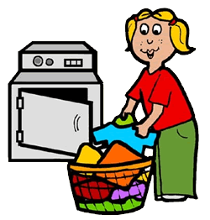
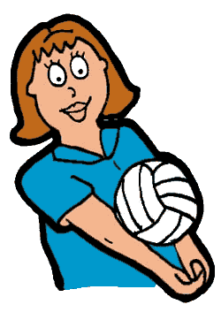
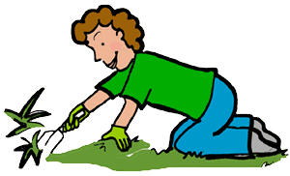

Developing hand and grip strength

Children and young people with motor difficulties may have weak muscles in their hands and fingers. They often find fine motor activities difficult and avoid doing them. This means they don’t develop hand and grip strength at the same rate as their peers.

Children with poor hand and grip strength tend to use awkward whole-hand grasps to pick up and manipulate objects. This affects the accuracy of their hand movements and means they have difficulty with the more refined fine motor movements needed to, for example move a pencil or do up buttons. They also have difficulty open packets, turning a door handle, holding objects securely and pulling up a zip.

Activities that involve pinching or gripping against resistance will improve hand and finger strength. Many activities can be incorporated into the child’s daily life so that strength is gradually built up. These can include:
- Wringing out wet clothes, a flannel or a sponge when washing the car.
- Pegging washing onto the line
- Moulding scone or biscuit dough into rounds and flattening to bake
- Pressing shaped cutters into play dough
- Rolling dough into a sausage and slicing rounds with a knife
- Paper folding activities – make a paper fan, boat or hat
- Use Rubber stamps from the pound shop
- Keeping frequently-used items (e.g. cutlery or biscuits) in containers with flip-top or screw-top lids. Practice un doing jars and plastic bottles
- Scrunching paper into balls before throwing it into a bin
- Using trigger-action spray guns to water plants
- Using salad tongs to serve out lunch or sort objects such as cotton wool balls

Games for younger children include:
- Stickle bricks
- Magnetic blocks
- Pop and lock beads
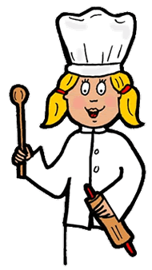
- Nut and bolt construction sets
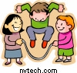

Developing finger skills

The development of fine finger skills is dependent on a person’s ability to stabilise their trunk and shoulders while moving their hands. Over time movements become more controlled, developing from the shoulders to the elbow, the wrist, and then the fingers. Some children with motor difficulties are slow to develop the fine motor control needed for writing, managing buttons and using scissors. Hand movements are often larger than necessary and are therefore less accurate. They often use unusual grips to hold their pencils and other tools.

Children with poor fine motor skills will benefit from activities that put weight through their shoulders and arms before carrying out fine motor tasks. You should also make sure that your child is sitting on an appropriately sized chair with their feet supported. This allows them to concentrate on their hands rather than their balance.
Activities to stimulate the hands include:
- Clapping games
- Catching soap bubbles between the hands
- “Drawing” with the fingers in a tray of sand, rice or shaving foam

Activities for finger isolation (pointing) include:
- Popping soap bubbles that land on the floor
- Pressing stickers onto a page
- Poking holes into a lump of dough
- Finger painting
- Finger puppets
- Playing with push-button toys, calculators or an old typewriter
- Pointing out hidden objects in a picture book

Activities for developing a pinch grip include:
- Using tweezers to sort out small objects such as buttons and coins
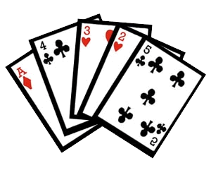
- Using a plant sprayer to wet sand, walls or the pavement
- Pinching pieces of dough from a large lump
- Sorting out the change from your purse
- Make a hedgehog by pushing used matchsticks into a lump of dough
- Dealing cards

Using two hands together

Many young people with motor difficulty find it hard to use both hands together. They have often been late to decide which their dominant hand is, so don’t get used to using one hand actively while supporting the activity with their other hand. They find it difficult to use scissors, do up buttons, tie laces and use a knife and fork. Often these young people don’t support the paper when writing – sometimes they press down hard with their writing hand to stop the paper from slipping. They may also find it difficult to reach their hands across the middle of their body.


The following activities will help young people to use both hands to perform different movements at the same time.
- Playing musical instruments such as the maracas and drums or make and play homemade instruments.
- Ask your child to mix batter or beat eggs while holding the bowl steady with one hand.

- Lego bricks encourage pushing and pulling with both hands together.
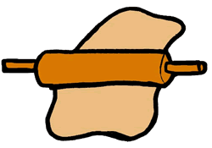
- Use clay or play dough to roll snakes with both hands. Encourage your child to adjust their hand pressure to make sure the snake is even in size. Rolling pins can also be used with two hands together.
- Lots of water toys encourage two-hand use. These include squeezing objects to squirt water and using pumps or levers while holding the toy steady.
- Lacing and sewing activities using plastic canvas, cards with holes punched in.
- Provide stencils or templates for your child to draw around while holding the shape steady. You can make these out of card.
- Practice cutting using stiff paper and straight lines before moving on to thinner paper and curved lines. Make sure your child is sitting on an appropriately sized chair. Use old birthday cards and zigzag scissors to cut interesting shapes for gift tags or collages.
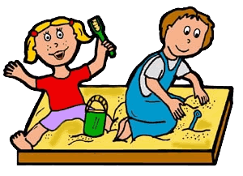
- When playing in the sand provide a two-handled sieve. Put some objects (e.g. shells) into the sand and ask your child to find the shells by shaking sand through the sieve.
- Make bead necklaces using small dried pasta tubes and laces
- Provide wind-up toys for bath toys

