Do you have an anxious child?

Does any of this sound familiar?
- Constant worrying
- Complaints of frequent headaches or tummy aches
- Clinging, crying and/or tantrums when separating from you
- Avoiding places or situations due to fears
- Sudden panic attacks
If so, your child may be experiencing anxiety.
The good news is …
- Anxiety is normal – we all experience anxiety from time to time. It can help us stay alert, keep safe and be successful in stressful situations. So, we all need small doses of anxiety in order to function effectively. It only becomes a problem when feelings of anxiety are so frequent and severe that they begin to interfere with our ability to engage in everyday life.
- Anxiety is not dangerous – the physiological effects of anxiety can feel very uncomfortable and overwhelming but it is helpful to remember that these feelings are temporary and will decrease eventually. These sensations are our body’s natural response mechanism when we are alerted to danger.
- You are not alone – research suggests that in an average class 5 pupils will have experienced significant anxiety.
- Anxiety can be successfully managed – with the appropriate strategies and support anybody can gain confidence in managing their anxious feelings enabling them to face their fears.

There is a lot that parents can do to support their child in managing their anxiety
- Encourage your child to speak to you openly about their worries. If your child feels listened to, accepted and understood this can go a long way towards helping them to reduce their anxiety. Sharing a worry and saying it out loud can also reduce its power! BUT, avoid showing your own worries about the situation in front of your child or talking to others about it in front of your child. This may make their own worries even greater. They will take their lead from you.
- Try not to accommodate your child’s anxiety by allowing them to avoid certain situations or offering excessive reassurance. These responses can actually make anxiety worse in the long run as they allow the fear to grow. Instead try to help your child to gradually face their fears with your support and encouragement. Remember, the goal is not to eliminate anxiety altogether but to help your child to learn how to manage it. Try to find solutions together.

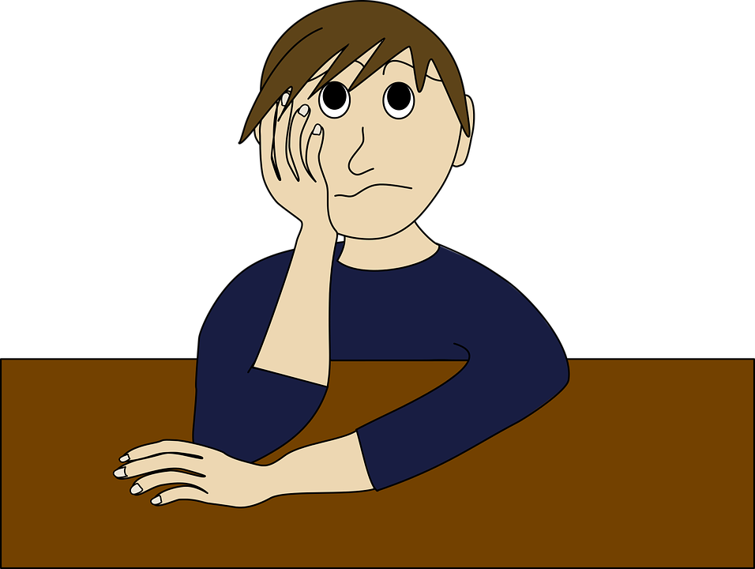

- Establish an emotionally healthy home. Maintaining consistent routines and boundaries will help your child to feel safe and secure. Don’t be tempted to ‘go easy’ on your child and allow them to break the rules because they are anxious. Model how to manage anxiety in a calm, positive manner yourself and talk to your child about the strategies that you used in order to cope. Build time into the day for your child to engage in calm and relaxing activities.
- Establish good routines. Encourage your child to get plenty of sleep, have good relaxing bedtime routines and encourage daily exercise. Having a healthy diet and interests outside of the family home can also help.
- Encourage your child to name their anxiety. Children often find it easier to identify anxious thoughts and feelings if they give these a name (e.g.’ worry monster’). When your child is anxious you can ask them about what the ‘worry monster’ is saying and help them to replace these thoughts with more helpful, balanced ones. Try to turn negative thoughts in positive ones.
- Reward your child for being brave. If your child takes a step towards facing their fear, however small, ensure that you give them plenty of praise and encouragement.
- Teach your child techniques to help them feel more relaxed. These can include muscle clenching and relaxing, controlled breathing, visualisation and distraction. You can also use activities they enjoy such as listening to music, drawing and colouring, spending time with friends, taking the dog for a walk etc.
- Speak to other people who may be able to help. Talk to your child’s school about your concerns as it is likely that the anxiety is manifesting itself in this environment as well, even if their anxiety is not directly related to school. They may be able to offer support themselves or from outside agencies who visit the school. If you have on-going, significant concerns about your child’s anxiety speak to your GP about the possibility of accessing more specialist support.

Useful Resources
Books:
All birds have anxiety – Kathy Hoopmann
David and the worry beast – Anne Marie Guanci
No Worries! – Lily Murray
The huge bag of worries – Virginia Ironside
The girl who never made mistakes – Mark Pett
When my worries get too big – Kari Dunn Buron
What to do when you worry too much – Dawn Huebner
The Panicosaurus - K.I Al-Ghani
Websites:
moodgym.anu.edu.am
anxietybc.com
worrywisekids.org
anxietyuk.org.uk
nopanic.org.uk
youngminds.org
nhs.uk
handsonscotland.co.uk
moodcafe.co.uk

Social, Emotional and Mental Health Team | Specialist Inclusion Support Service | Children and Young People’s 0-25 SEND Service | Learning, Skills and Progression | Children and Families | Solihull Metropolitan Borough Council | Elmwood Place | 37, Burtons Way | Solihull | West Midlands | B36 0UG | Office: 0121 704 6690 |www.solihull.gov.uk |

